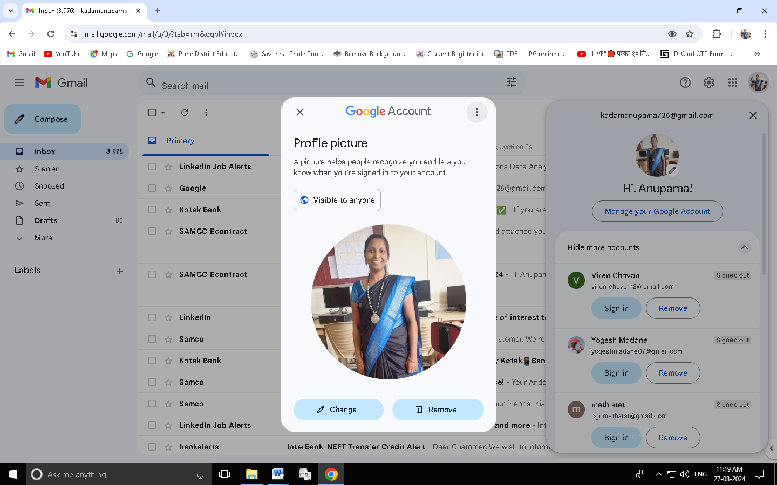
RESUME

Ms.Anupama Mohan Kadam
Email : kadamanupama726@gmail.com
Mobile : +91 9657717825

Objective:

To work in a challenging atmosphere by exhibiting my skills with at most sincerity and dedicated smart work for the growth of esteemed organization along with mine.
- B.G.College,Sangvi,Pune
Work Experience:
Lecturer – From 2015 to till Date
- A.M.College,Hadapsar,Pune
Lecturer – From 2006 to 2013
Research paper:

- “Time Spend Via Virtual Entertainment by Students” published in Journal of Oriental Institute ISSN :0030-5324 Vol 72.

Technical Skills:

Operating Systems | Windows 7/10
Programming Languages | Python
Knowledge In Technology | - Data Analysis with Python  - Data Visualization with Python  - Machine Learning with Python(Linear Regression ,Logistic Regression,KNN, k Means Clustering, PCA,  Decision Tree, Random Forest, Bayesian)  - Depth Knowledge in Probability and Statistics  - Ms word
Tools | - Jupyter Notebook

Educational Details

Examination | Board/ University | Year of Passing | Percentage
M.Sc.  Statistics | Shivaji University,  Kolhapur | 2006 | 62.33%
B.Sc.  Statistics | Shivaji University,  Kolhapur | 2004 | 64.20%

Achievements
- Certified Course – Data Science with python
Extra Curricular Activities

- Guided Students for Science Exhibition
- One State Webinar Attended
- Four National Webinar Attended
- One International Webinar Attended
- Member of Criteria-IV & Exam Committee.
- Member of Sport Committee
- Member of NSS Committee
- Attended NSS Camp at post Owale, Pune

Personal Details

Sex : Female
Date of Birth : 11/01/1984
Marital Status : Married
Nationality : Indian
Languages Known : English, Hindi and Marathi

Address

C-211,Swapanpurti phase II , Pimpri,Pune-17

